**RAIN WORRIES**

George John, vice chancellor of Birsa Agricultural University, Ranchi, on monsoon worries

As told to Rudra Biswas

* Published 15.06.15

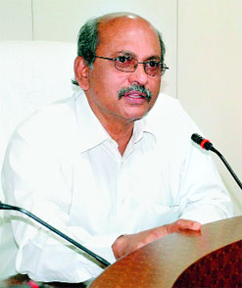**10 Questions**

**TT: IMD has downgraded its monsoon forecast. Should we worry?**

GJ: Over the past five decades, Jharkhand has always received abundant rainfall, though in some years the rains have been erratic in pockets. Unless there’s a food crisis, there’s nothing to worry

**Has BAU drawn up any contingency plans?**

If the rains get delayed past June-end, BAU’s Krishi Vigyan Kendras will advise farmers to sow short-  
duration paddy and other crops. In case the rains are delayed beyond August, we will advise farmers to   
abandon sowing paddy and instead grow horse gram (kulthi in local parlance), marwa (a wheat substitute), corn, ragi, maize and pulses

**Why push for coarse grains, which have very limited markets?**

Marwa, millets may be coarse grains, but they have high nutritional value

**Even the sensex fell when IMD lowered monsoon forecast.**

For BAU, the ongoing panic is a reminder to initiate further research into drought and pest-  
resistant crops

**What are you working on?**

We are setting up a Centre for Advanced Studies in Tribal Agriculture to tap traditional know-how on farming and integrate it with technology

**Are you working on genetically modified crops?**

Genetically modified crops are the only answer to the rising demand for food. We are drawing up   
research proposals. Once ready, we will approach the Indian Council of Agricultural Research

**Shouldn’t BAU also focus on organic farming?**

Organic farming cannot meet the demands of a growing population. It’s okay to do it in pockets, but futile   
to pursue on a large scale

**What about funding?**

There is no dearth of funds for R&D provided we are articulate while presenting our case and meet benchmarks set by funding agencies

**Are farmers taking BAU advisories seriously?**

At BAU, we filter all the daily advisories and put out the best for our farmers through the Krishi Kendras

**Can BAU alone combat drought?**

No. The state government, banks and financial institutions and industry need to join hands to make agriculture a more attractive venture.